**Output to the console and operators** (use of printf)

Write a Java program to accomplish each of the following tasks:

1. Prompt the user for a decimal point number.
2. Assign the number to a suitable variable.
3. The output of the program should match the following…..

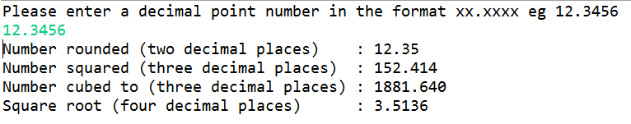

**Note**: You will need to perform several maths operations to produce the required output. But there are in-built Java functions that would allow you to do some of these (***Hint java.lang.Math***)

Also always try to write efficient code... do you need to create a new variable to store the result of each operation before outputting to the console?

**IF.. ELSE Statements (Masters grading)**

Write a Java program to accomplish each of the following tasks:

1. Prompt the user of the program for a final mark for a Masters student (between 0 – 100).
2. Assign the number entered to a suitable variable.
3. Using only IF .. ELSE statements output the Masters Classification corresponding to the number entered by the user.

0-49 Fail

50-59 Pass

60-69 Merit

70-100 Distinction

Note : if the user enters a number outside the range output a suitable error message

**Remember to Test your program.**

**Output examples**

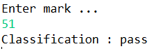 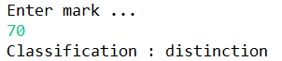

**More Selection statements**

**Age checker**

Prompt the user for his/her age. Then check if the user is **over 17**. If so, then prompt the user for a **name**. Then output the user’s inputted **name** and **age**. Otherwise, if not over 17 then output “**too young to continue**” (i.e. do not prompt for name). In addition, ensure that the user **does not enter a negative number or 0 for age**. (if so exit the program gracefully with “**sorry don’t recognise your input**”.

**Voting system**

Use an **if … else** statement*:* to check a user input value into a voting system. The user should be presented with two options ‘**con’** and ‘**lab’**. (Representing Conservative and Labour). If the entry is **con** then output “**Voting registered for Conservative**” and “**Voting registered for Labour**” upon ‘**lab’** entry. Ignore the case that the user enters these values.

(Your program should use the conditional operator to help convert the input value (con or lab) to Labour or Conservative respectively.

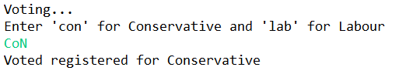

**Also, add some validation to ensure the user cannot register a vote if they type any other entry(see below)**

